# Verification Process

1. Verifier logs in to the system

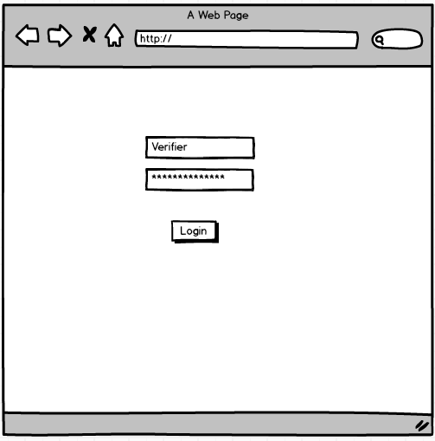

Figure 1

1. He can see the list of Invoices which are pending verifications

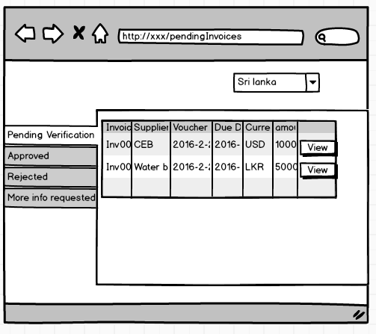

Figure 2

1. He clicks on the view button and Invoice edit page will be opened.

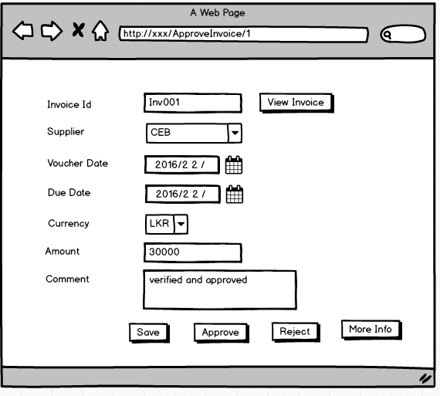

Figure 3

* 1. User clicks on View Invoice Button and the scanned invoice will be opened as a pop up

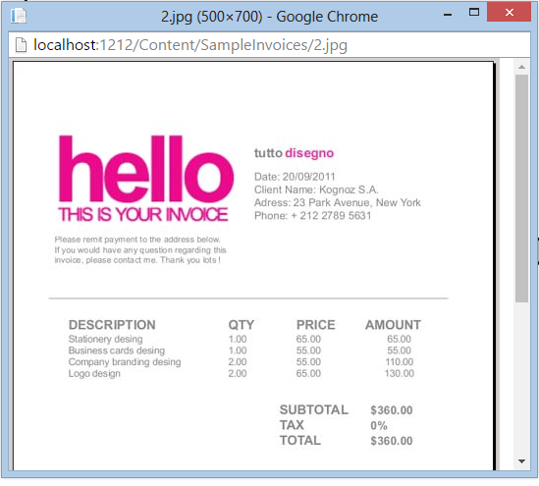

* 1. User Clicks on Save button after modifications and he will redirect to pending invoices page (*Figure 2*)
  2. User click on Approve button and he will redirect to pending invoices page (*Figure 2*)
  3. User click on Reject button and he will redirect to pending invoices page (Figure 2)
  4. User clicks on More info button will show him multiple options.

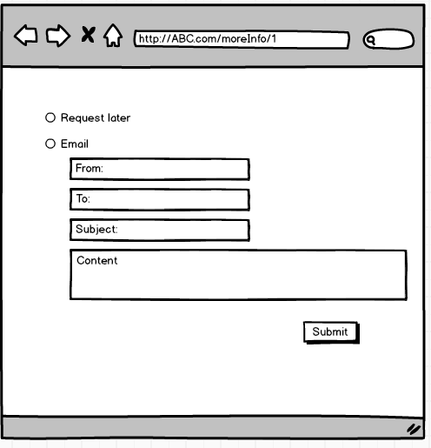

# Approval Process

1. Approver logs in to the system
2. Approver can see the list of invoices which are pending approval

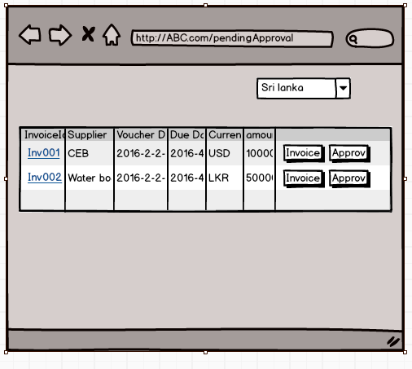

1. Approver clicks on the invoice id and he will redirect to Invoice details page.

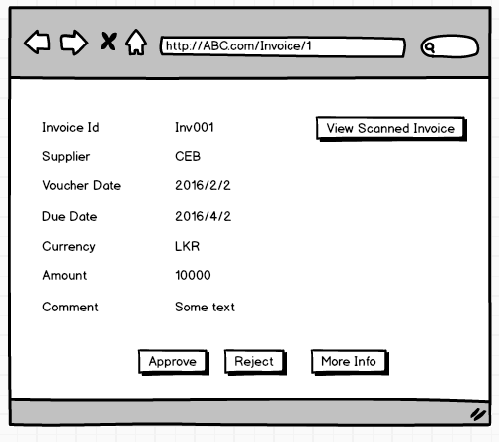

* 1. Approver clicks on more info button to request more info from supplier or approver

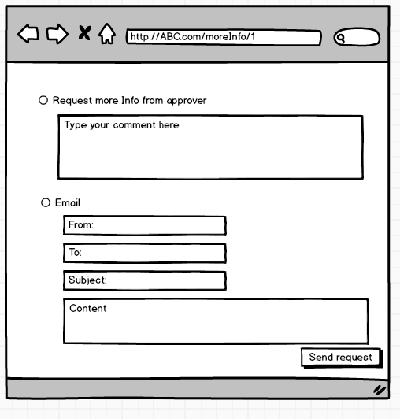

# Rejected Invoices

1. Finance team member view Rejected invoices. He will send them to archive after finance team receive new invoice for rejected one.

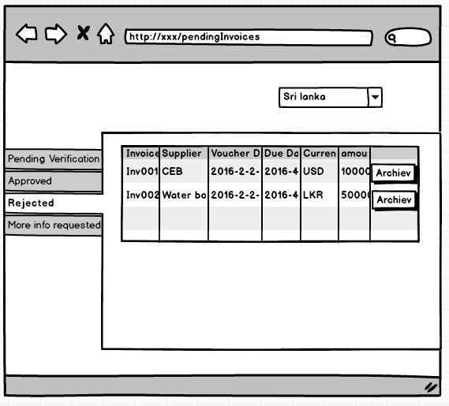

Approved Invoices

1. Approved invoices will be coded and send to visma
2. The invoices sent to visma can be revert and send back to Visma